

Project Plan and First Increment

Fall 2016

Team 14:

**The Invincibles**

* GOPALA KRISHNA AVINASH TUMMALAPALLI
* SIRISHA MANTHRAMURTHY
* SAI KARTHIKEYA ADDAGADA
* SAI TEJASWEE REDDY PASHAM

# 1. Introduction

**One Stop for all media**

People end up using many applications, each for a specific kind of media. This is quite burdensome and frustrating sometimes. So here comes Medianizer, where a plethora of media is brought onto a single platform, so that the customers are likely to fetch desired media in the blink of an eye. Medianizer is a universal application, where you can avail a wide range of access over media. This is a collection of media such as Music, Videos, Photos and Books where users can rent or purchase media.

# 2. Project Goal and Objectives (revised)

**2.1 Overall goal:**

The main goal of this application is to provide access to all the media like Music, Videos, Photos and Books over a single platform where people can buy or rent the desired media.

**2.2 Specific objectives (problem statement)**

2.2.1. To create a unique platform where the users can get all types of media.

2.2.2. To enable search via voice.

2.2.3. To let the user purchase or rent the desired media.

**2.3 Specific features**

**2.3.1 Search for E-Books:** This feature enables the user to search for books related to a genre or the year of its release.

**2.3.2 Search for Movies:** This feature enables the user to search for movies related to a genre or the year of its release.

**2.3.3 Search for Music:** This feature enables the user to search for music related to a genre or the year of its release.

**2.3.4 Purchase Media:** User can rent or buy media.

**2.3.5 Voice Search:** User can voice search for media.

**2.4 Significance**

The application provides access to a wide range of media like Music, Videos, Photos and Books over a single platform.

# 3.Project Plan

1. **Zen- Hub Screenshot:**

For the first increment we have issues regarding creating a login page, registration page, integrating Facebook login into the application, working on unit test cases.

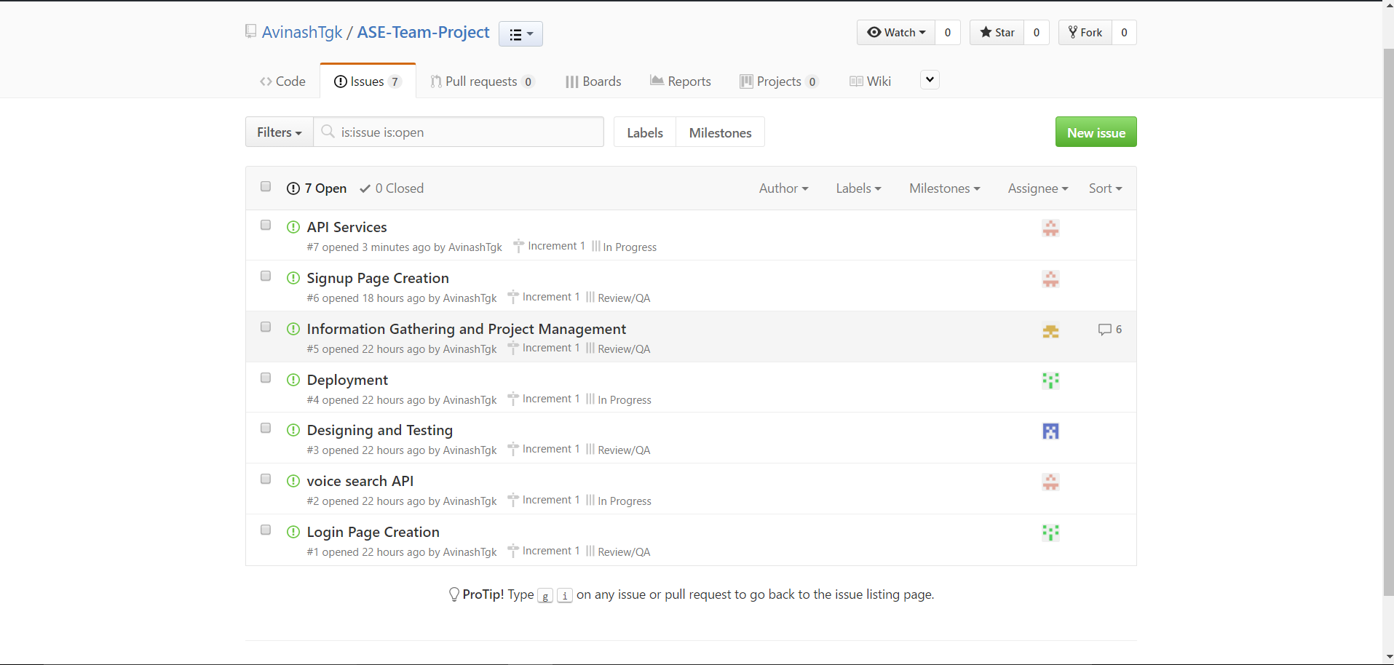

1. **Project Timeline, Members, Task Responsibility:**

Below is the screenshot describing the new issues and issues which are in progress state, done state and all other states too.

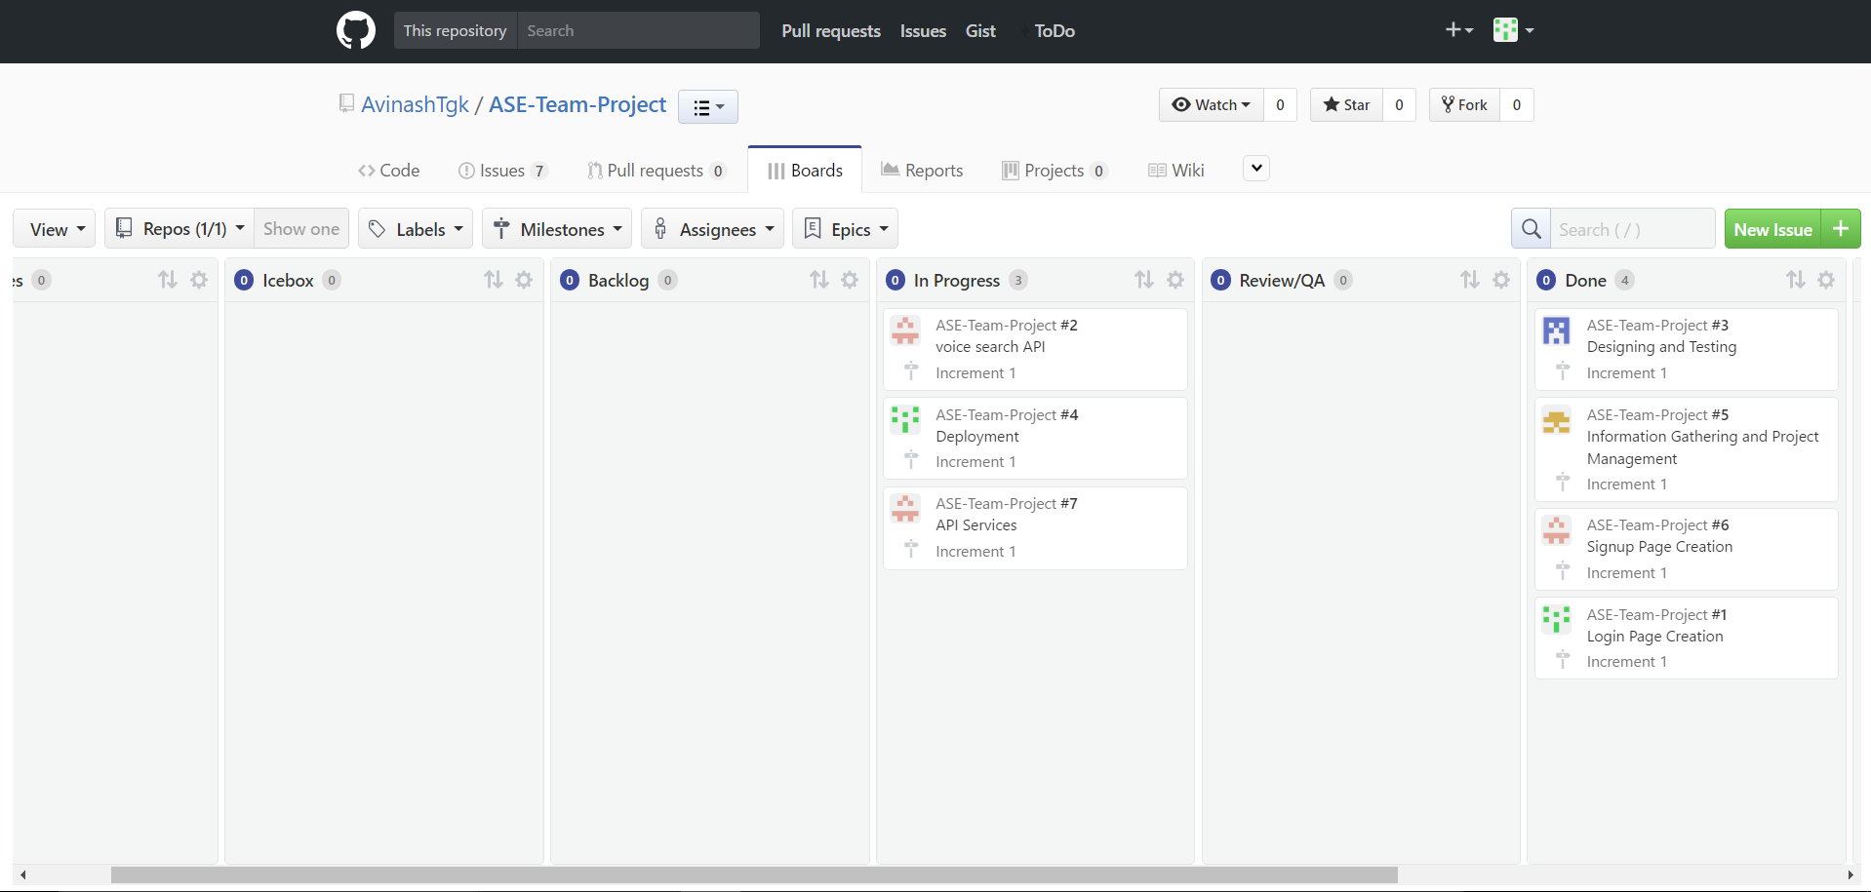

1. **Burn-Down chart**

Burn-Down chart is created for the above described issues as shown below:

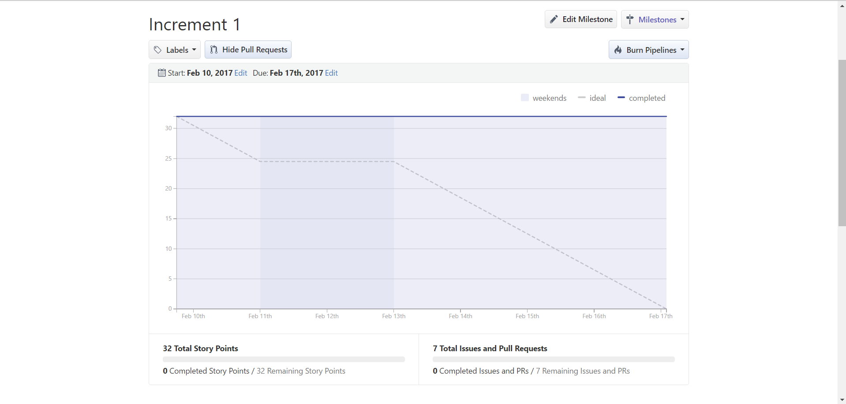

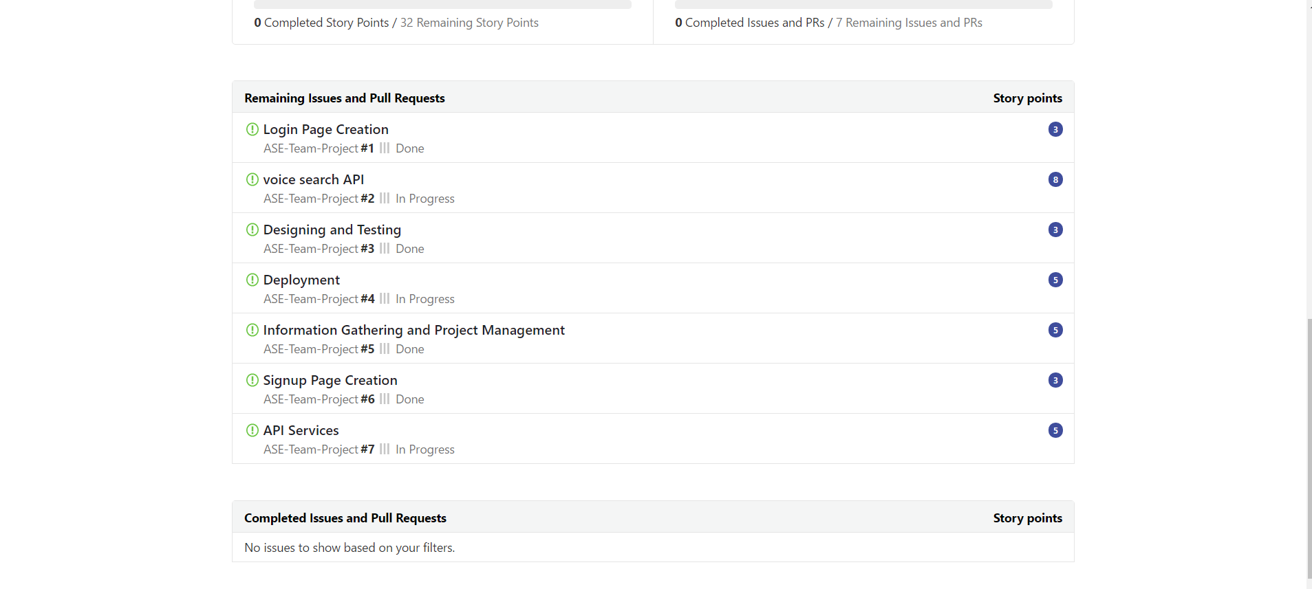

# 4. First Increment Report

**4.1 Existing Services/REST API**

**4.1.1 API’s Used**

**4.1.1.1 Voice Search API:**

Voice Search API is used in the application which accepts the voice search commands and renders the desired results.

**4.2 Detail Design of Features:**

**4.2.1. Wireframes**

**Login Page**

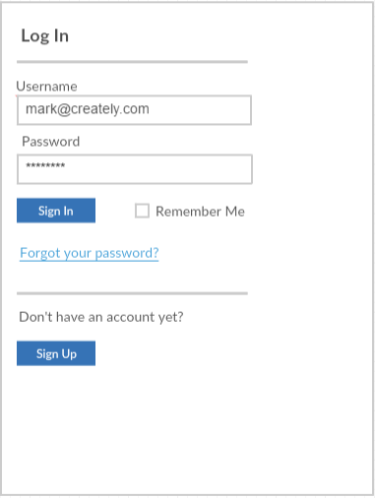

**Registration Page**

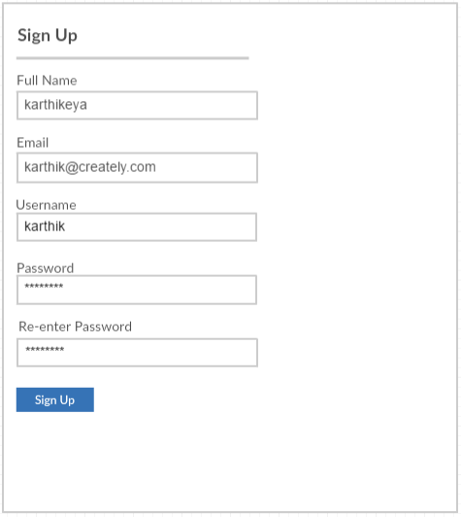

**Home Page**

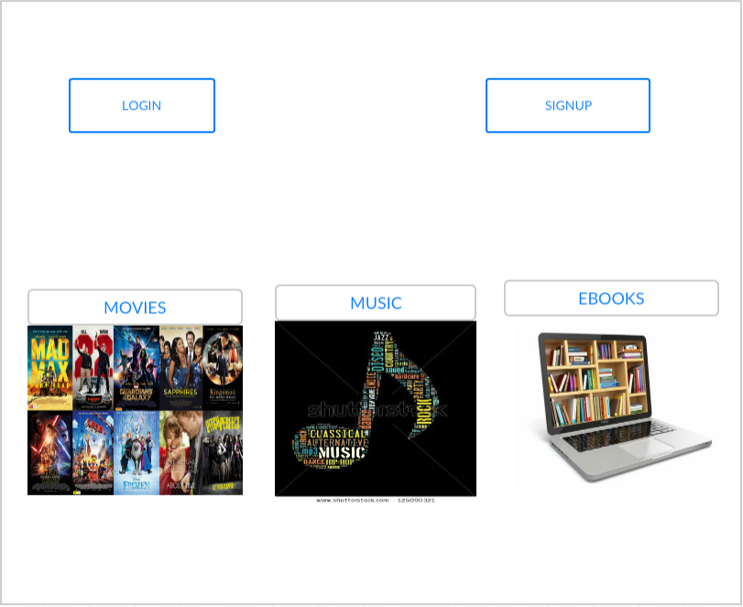

**Movie Page**

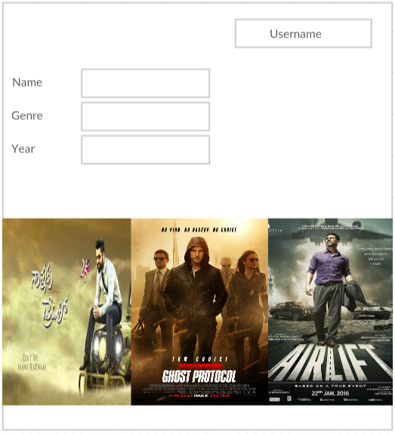

**Movie Item Page**

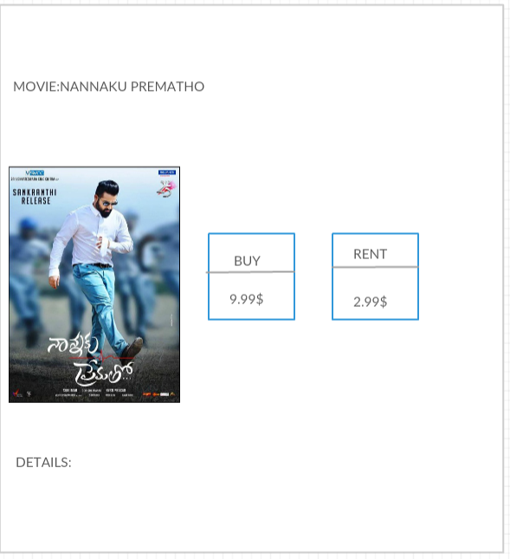

**Buy Page**

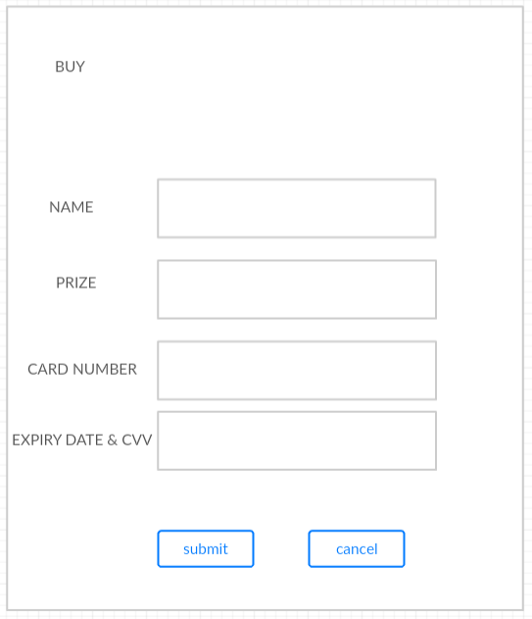

* + 1. **Class Diagram**

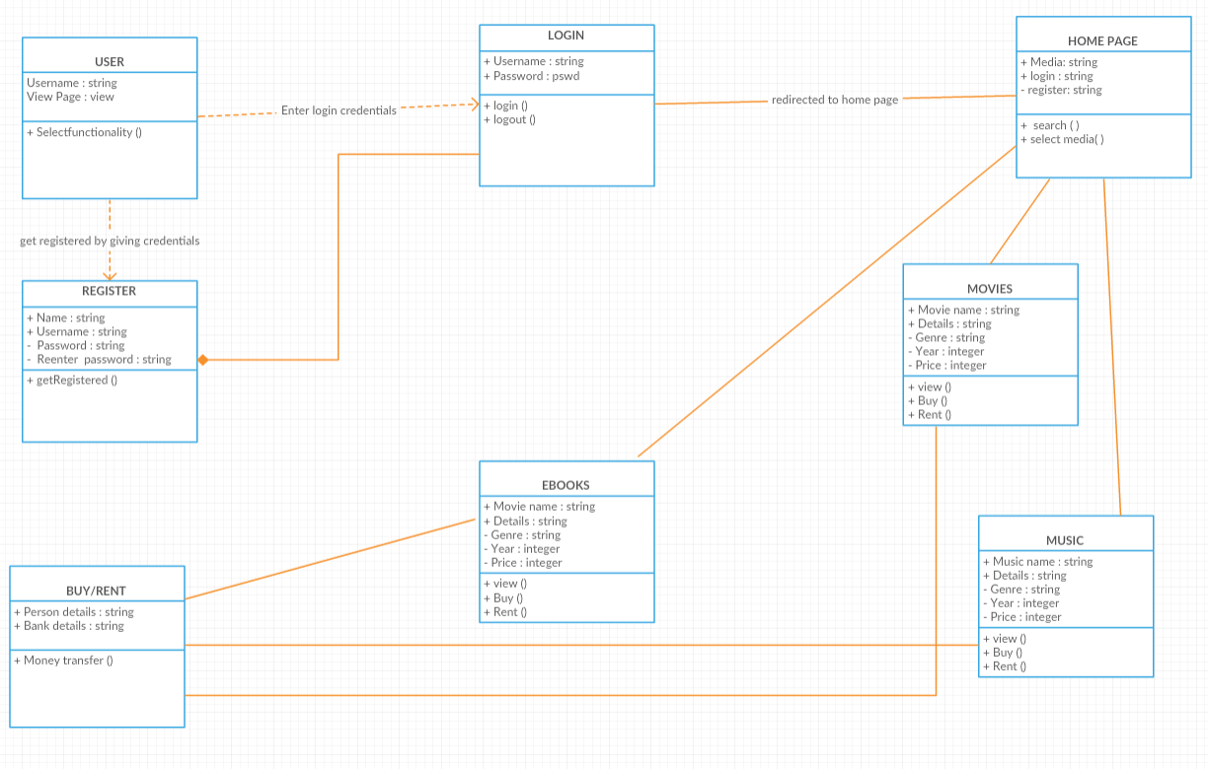

* + 1. **Sequence Diagram**

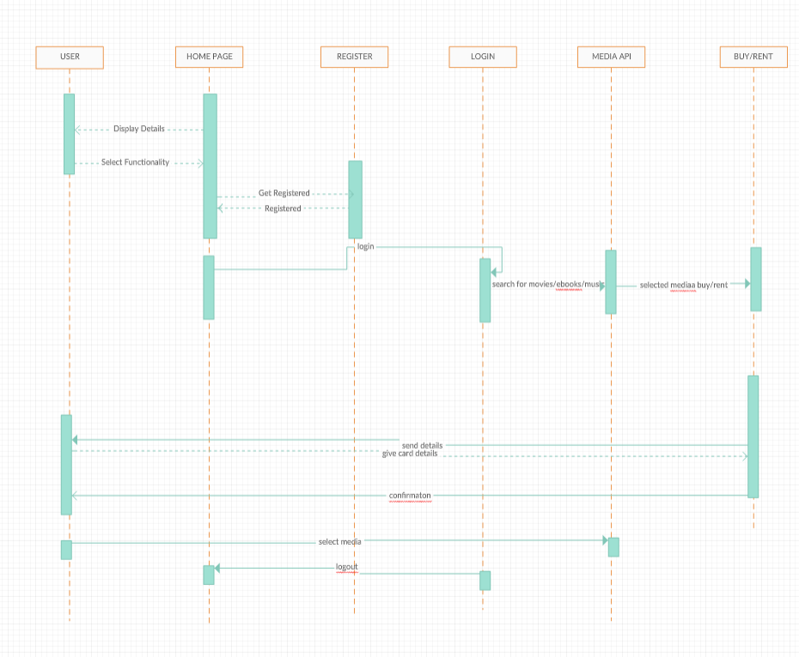

* + 1. **Architecture Diagram**

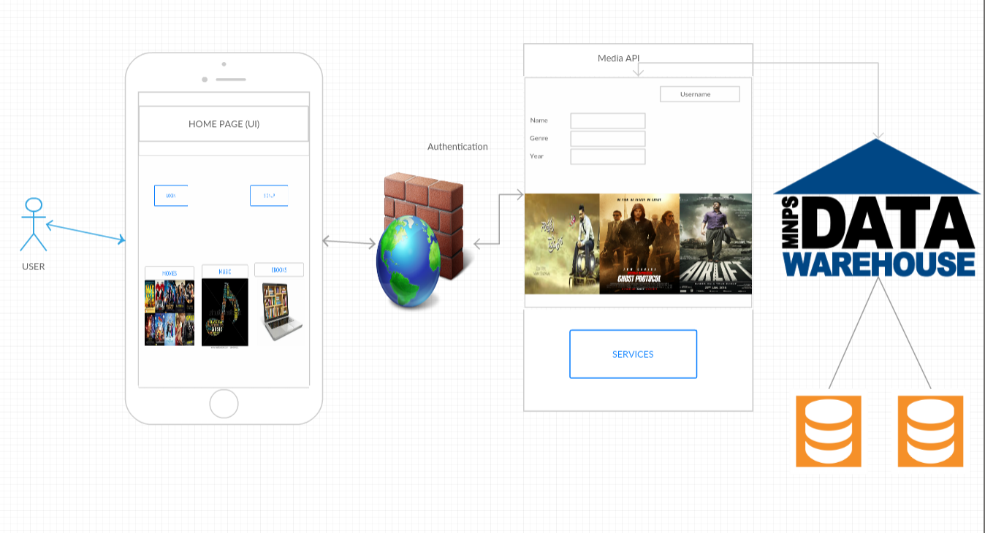

* + 1. **User Stories**

|  |  |  |
| --- | --- | --- |
|  | I want to | So that |
|  | search for a movie | I can access movies |
|  | search for music media | I can access music |
| As a user | Search for e-books | I can access e-books |
|  | Purchase media | Buy or Rent media |
|  | Voice search | Get results based on voice commands |

* + 1. **Unit Testing**

**Test Cases for Login and Signup page:**

|  |  |  |  |
| --- | --- | --- | --- |
| **Case** | **Test case Description** | **Expected Result** | **Actual Result** |
| Login | Enter invalid username and password | Error message should pop up saying invalid credentials. | PASS |
| Login | Enter invalid username and valid password | Error message should pop up saying invalid credentials. | PASS |
| Login | Enter valid username and invalid password | Error message should pop up saying invalid credentials. | PASS |
| Login | Enter valid username and password | Page should redirect to Home page | PASS |
| Signup | Email id format should end with @mail.com | Give error message incorrect email id format | PASS |
| Signup | Password of length 8 characters | Gives error message password is weak | PASS |
| Signup | Password and confirm password should match | If this succeeds it redirects to login page | PASS |

# 5. Implementation and Deployment

We have implemented the Medianizer application in Android Studio onto an emulator. Following screenshots describe the flow of the application.

**5.1** Our application, “Medianizer” in the menu.

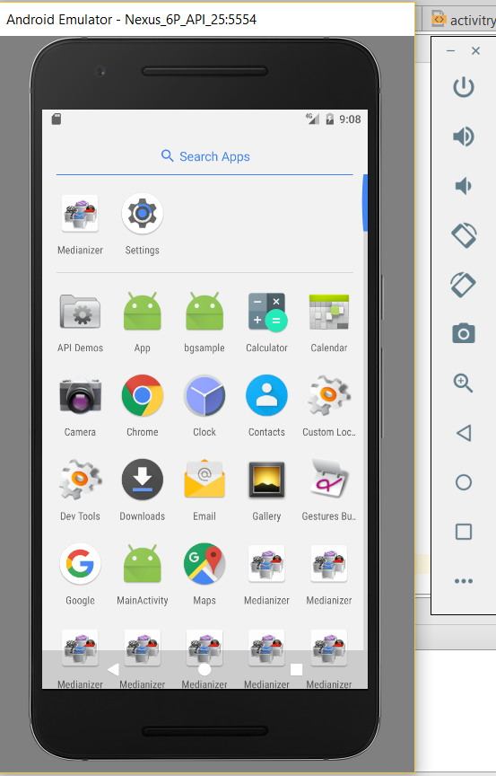

**5.2** By clicking on the application, the following login page appears.

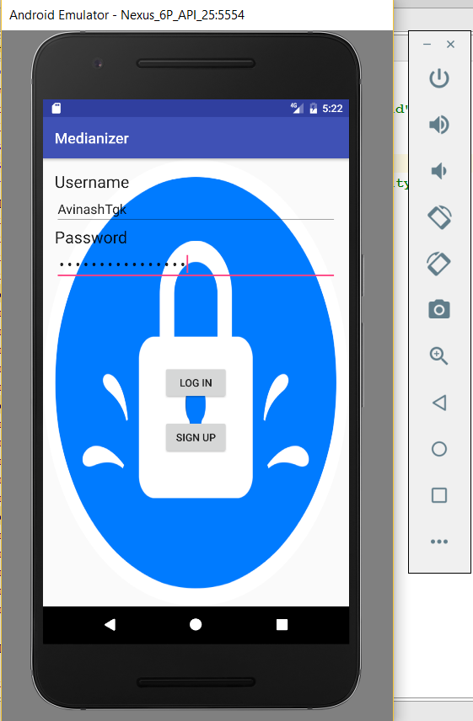

**5.3** If the user is new, on clicking signup the following form appears.

(with user details)

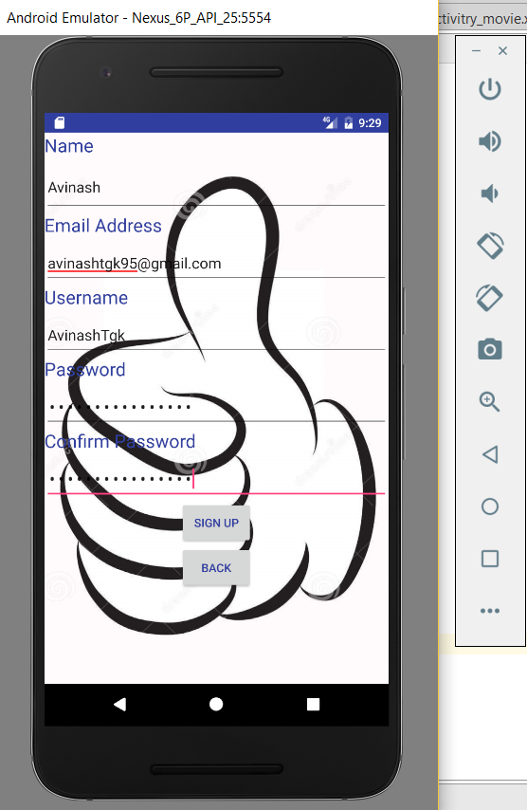

**5.4** Upon logging in, the following index page appears.

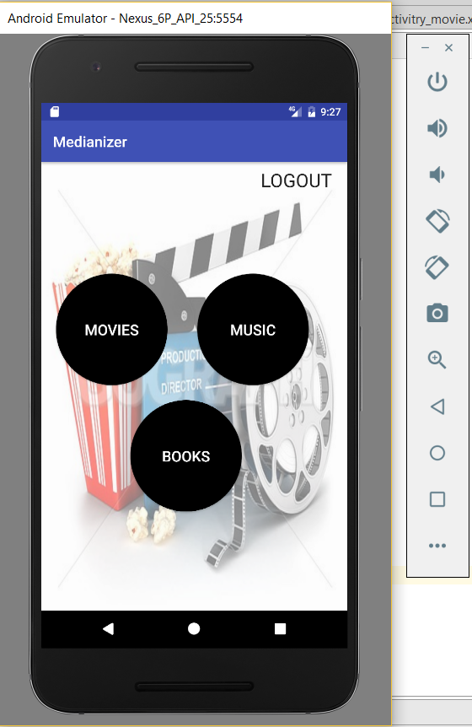

**5.5** On selecting the desired category, the respected page opens.

(similar pages for all categories)

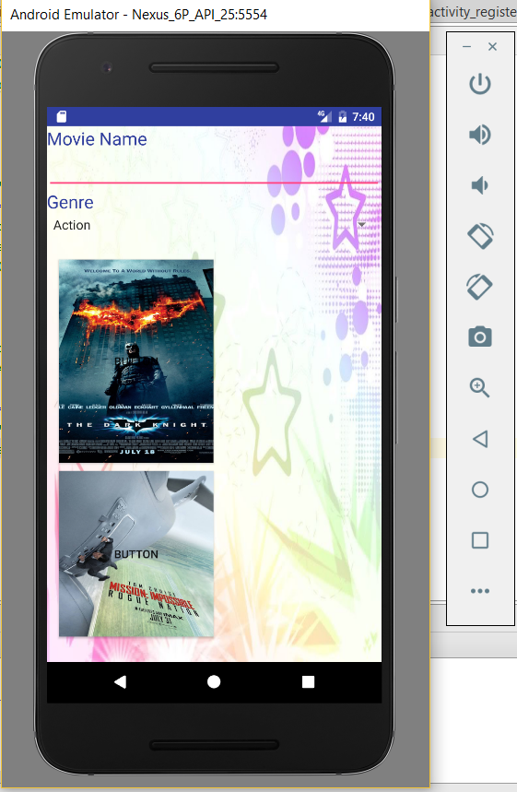

**GitHub wiki page URL**: <https://github.com/AvinashTgk/ASE-Team-Project>

# 6. Project Management

**Implementation status report**

**Technologies Used:**

Android SDK, J2EE, XML.

**Work Completed:**

* Design and Architecture of the Application
* Login and Registration using Android

**Work to be Completed:**

* Searching for the API useful for the application
* Integrating the API with the application.
* Improving the User Interface of the application.

**Contributors:**

* Sai Karthikeya Addagada – 25%
* Sirisha Manthramurthy – 25%
* Sai Tejaswee Reddy Pasham – 25%
* Gopala Krishna Avinash Tummalapalli – 25%

**Contribution:**

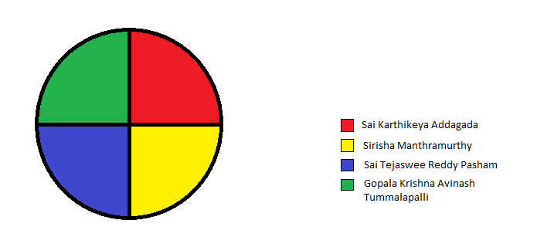

**7. Bibliography**

* <http://creately.com>
* <https://developer.android.com/studio/index.html>
* <https://console.developers.google.com/apis/dashboard?project=hale-inn-158921&duration=PT1H>
* <http://stackoverflow.com/>
* <https://www.w3.org/standards/xml/>